Title:
Quality Plumbing Services in Houston - Installation And Repair
Description
Get Houston's most reliable plumbing services for installation and repairs. We offer hot water heater repair, installation, leaks, plumbing & drywall repair.

https://houstoncustomcarpets.com/services/plumbing-houston/ | plumbing services Houston | 320
 | plumbing service near me | 9.9k
 | Houston plumbing services | 170
 | plumber in Houston | 1.3k
 | Gas line plumbing | 390
 | Drain Cleaning Services | 2.9k
 | water heater service | 2.9k
 | plumber installation | 1.9k
 | plumber repair | 3.6k
 | plumbing sewer line | 390

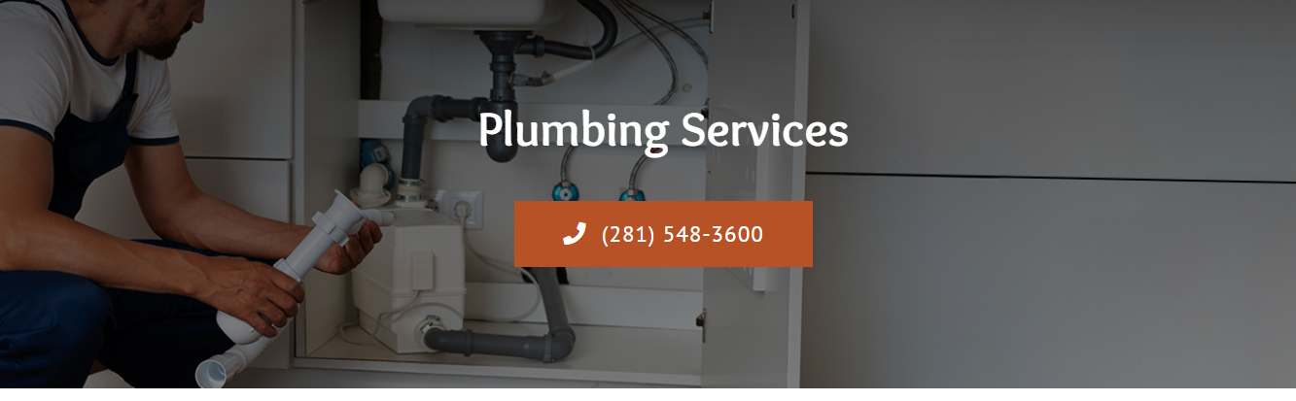plumbing services Houston (h1)

Searching For Plumbers in Houston? (h2)

Do you need the best plumbers who can solve any plumbing issue in Houston? Houston Custom Carpets has what you seek in plumbing services in Houston. Our team of plumbers is always ready to help with plumbing-related problems such as simple drain repairs to complicated installations. Ready to breathe a New Life into Your House with our highly skilled plumbing experts?

Consult Now

Do Not Let a Clogged Drain Ruin Your Day (h2)
A clogged drain is one of the most annoying experiences that can occur, and, consequently, it should be solved as soon as possible. That is why our plumbers in Houston are always prepared to help you. We utilize modern drain cleaning equipment to eliminate blockage to ensure that your drains are working smoothly. So do not let a clogged drain spoil your day; hire our Houston plumbing services today.

Call Our Experts Today
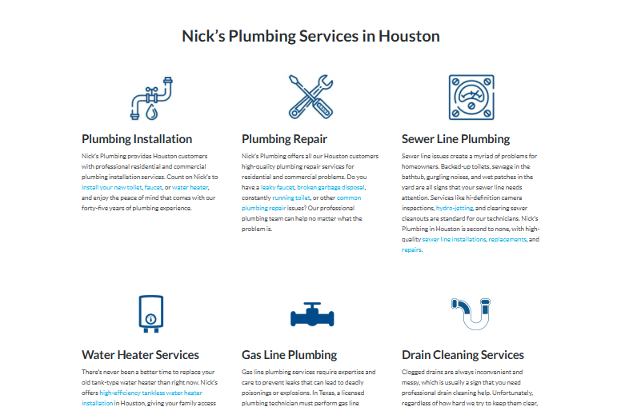

Houston Custom Carpets: Your Go-To Plumbing Service (h2)
If you are searching for plumbing service near me then you have reached the right place. At Houston Custom Carpets, our expert plumbers will make sure you will get what you came for.

Water Heater Services | Plumbing Repair
Do you have issues with your water heater or perhaps you need to change your heater? Our plumbers will provide details on all services centered on water heaters. Maintenance, repair, and installation of water heaters is our specialty and we deal with both gas and electric models including tankless water heaters. There’s no need to live with a non-functional water heater; call us now to schedule your service with our friendly technicians, all with incredible speed and efficiency. | Facing a plumbing emergency? Our plumbing repair services are always on, therefore you are always able to get our assistance at any time of the day. Professional plumbers are part of our expert team and they will provide you with a fast and effective solution to any plumbing issue you may be having. Whether it’s dripping from the sink or gushing from a pipe, we have got you covered. Ensuring that you receive the quickest possible response to any plumbing emergency is something we strive to do.
Drain Cleaning Services | Plumbing Installation
Having a clog that is very difficult to clear, one that does not seem to be getting out of the way anytime soon? Our team of experienced plumbers has most of the advanced methods of drain cleaning that include hydro jetting, CCTV drain inspection, and drain snake services to unclog most of the extremely stuck-up drain pipes. In that case, we give our word that we will leave you fully satisfied and your drain will be clear once again, so you can live without any kind of headache. | Whether it is your new home or established office or are you constructing and upgrading your plumbing system? Our plumbing installation solutions involve issuing planning permission for a new plumbing system, developing and implementing the plumbing system as well as the continual checking and supervision of the new plumbing system in residential, commercial, and industrial buildings. We utilize quality materials and cutting-edge technology to ensure your plumbing system is efficient and effective.
Sewer Line Plumbing | Gas Line Plumbing
Sewer line issues are very serious problems for your property; the sewer line could be broken or plugged. The plumbing sewer line services that we offer are meant to fix or replace sewer lines as effectively as possible. Some of the tools we employ include pipe relining and trenchless sewer repair to enable us to complete the job without causing much disturbance on your property. Don’t let pollution foil your sewer system and your wallet; let us help you prevent expensive repairs. | At our company, the plumbers we employ have the expertise in handling the gas lines for your homes or commercial buildings through installation, repair, or even maintenance. If you require a new natural gas line for an appliance or you need an examination of your current natural gas line, we’ll make sure that you have a safe and efficient gas system. When it comes to gas line maintenance, don’t take any likelihood; let the professional plumbers at our company do it for you.

Cover an Extra Mile With Our Plumber Repair Experts (h2)
At Houston Custom Carpets, apart from plumbing services for clients, our allegiance to our customers is our specialty. It is important to know that a plumbing problem is one of the most frustrating things you can go through and that at our company, our workers do all they can to make sure you’re more than satisfied with the solutions we offer. As for time management, we are always punctual. Moreover, we are sure to provide you with the best plumber installation services than anyone else in Houston. Additionally, we make sure to communicate well with our clients right from the start. Our plumbers will always do everything possible to make sure you are fully satisfied with the work done.

Need a Plumbing Hero?

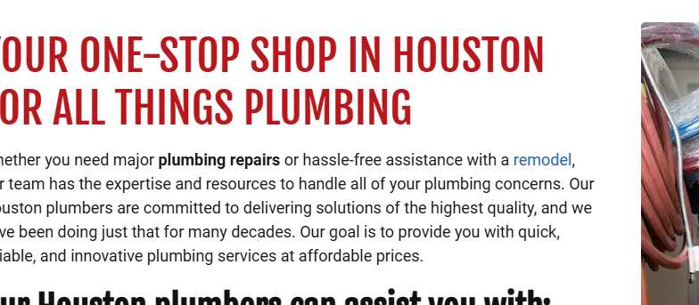

Houston Custom Carpets is Your One-Stop Solution for all Plumping Needs (h2)
Whenever you are in search of numerous plumbing services in Houston, you will not need to go through the difficulty of searching again because Houston Custom Carpets will provide you with complete plumbing services. Our plumbing services include repair and installation, drain cleaning, and maintenance among others. Our staff of experienced plumbers adequately addresses any type of situation that you may experience with your plumbing system. Therefore, whenever you require plumbing services that are professional and efficient then reach out to us immediately.
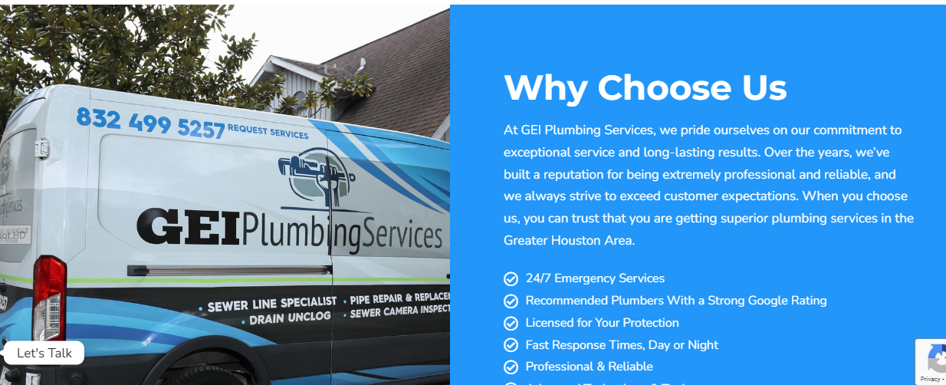

Why Choose Houston Custom Carpets? (h2)
Houston Custom Carpets plumbing services are unique because of three powerful factors: quality and experience as well as customer satisfaction. Our team of plumbers has become the best because we have qualified only professional staff who have ample experience in the plumbing sector and we use state-of-the-art equipment to overcome any plumbing challenges that we might encounter. That is why we give access to upfront pricing and various non-negotiable 100% satisfaction guarantees to all the clients.
- Free Estimates
- Advanced Technology & Tools
- Strong Google Rating
- Licensed for Your Protection
- Affordable Prices
- 24/7 Emergency Services
- Residential & Commercial Solutions
- Professional & Reliable
- Fast Response Times, Day or Night

FAQ's

How much time will it take to replace a water heater? (h3)
The time it takes to replace a water heater depends on the kind of water heater and size and the degree of difficulty in accessing the installation area. Generally, the process takes an average of 2-6 hours. The professionals from Houston Custom Carpets offer professional plumbing services that enable replacement to be done in the shortest time possible or in such a way that one does not have to change their routine.

What might be the cause of the sewage smell around my sink? (h3)
Stink emanating from the sink may be a result of a plumbing issue, for instance, a blocked drain, a faulty pipe, or a bad trap. If you have had a leaking problem, our plumbers can diagnose it and fix it for you as soon as possible.

How can I clear a stinking smell from my sink? (h3)
There are several things that you can try at home in a bid to eradicate the smell, they include; pouring boiling water down the drain, using a plunger, or application of a mixture of baking soda and vinegar. However, if the problem continues, the service of a professional plumber team such as Houston Custom Carpets is highly recommended.

How do your plumbers determine that you have a concealed water leakage? (h3)
We use various strategies to pinpoint hidden water leaks, including thermal imaging, sound listening, as well as pressure testing. Such methods help us identify the exact location of the leak and hence get repaired with much ease.

How soon will your team arrive after I request your services? (h3)
We want to appreciate that plumbing issues are emergencies and therefore must be resolved immediately. That is why we provide comprehensive emergency plumbing services. When you call for our plumbing services, a plumber will be dispatched to your location within the shortest time possible within a few hours. The duration it will take will also depend on your location and the availability of the plumbers.

